Open IIS Manager

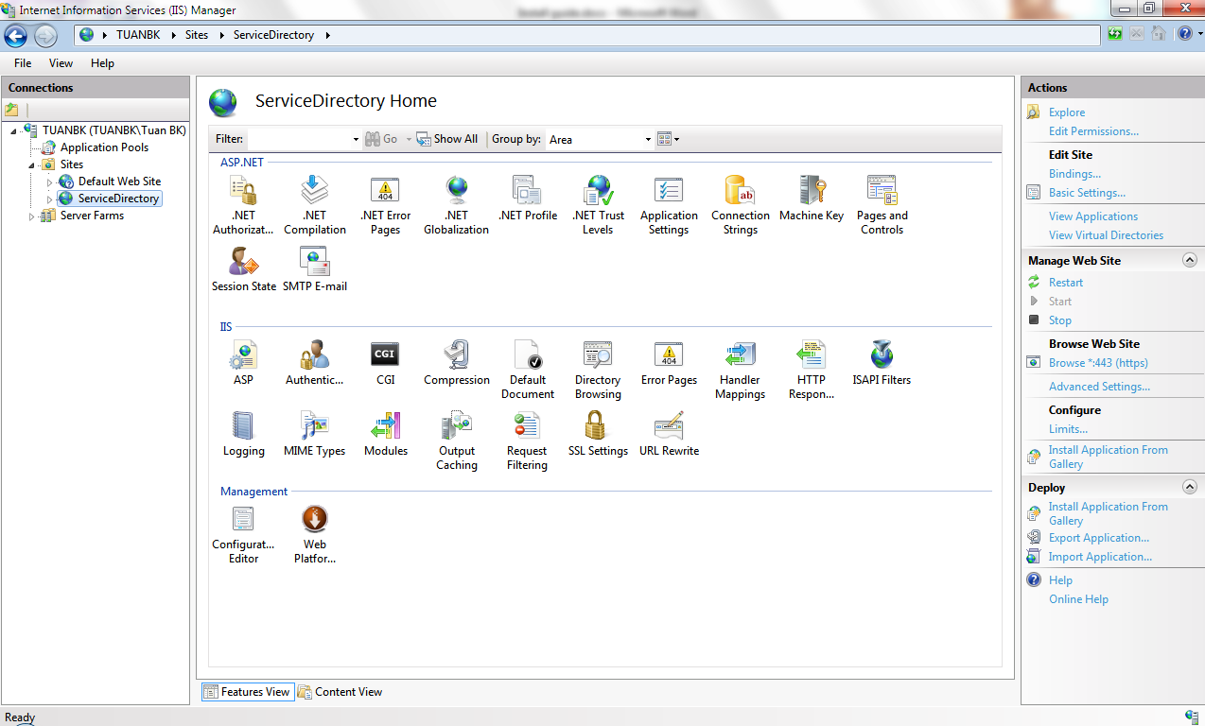

Add web site

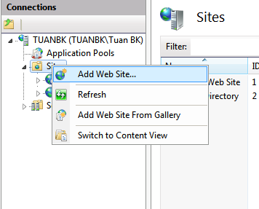

Choose Physical path, blinding type: https, cretificate: ...

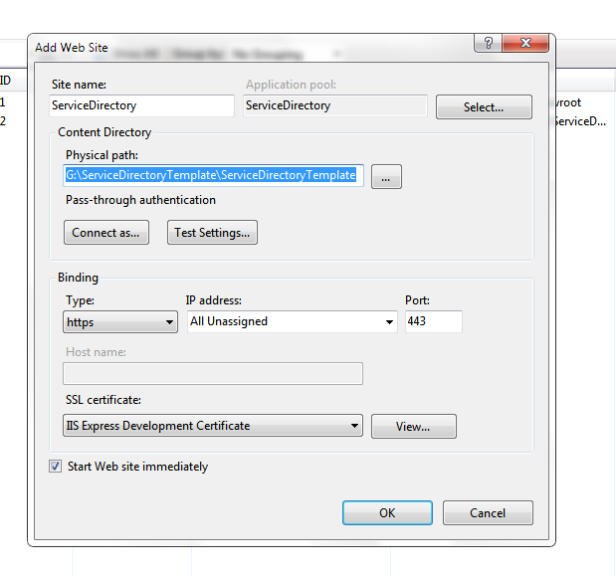

Setting site using .NET framework 4.0

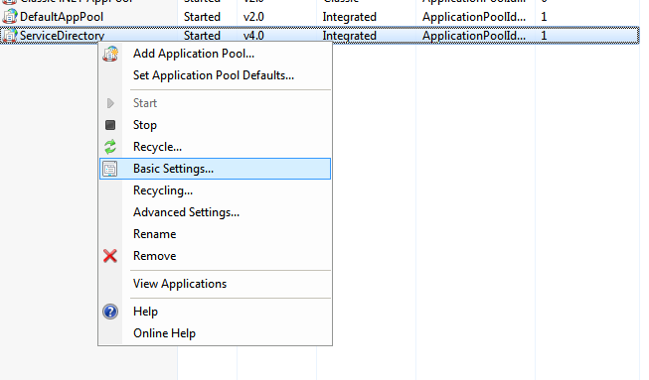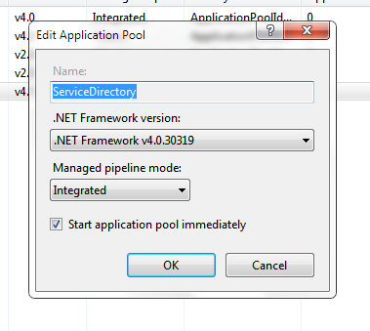

If can’t start website make sure the World Wide Web Publishing Service is start.

If cant access database.

Step0: Make sure SQL Server can use TCP/IP and allowed by Firewall. Restart SQL after config

Step1: Attach database in App_Data. Change name to ServiceDirectory

Step2: Open Web.config change connection string:

from

<add name="ServiceDirectoryConnectionString1" connectionString="Data Source=.\SQLEXPRESS;AttachDbFilename=|DataDirectory|\ServiceDirectory.mdf;Integrated Security=True;User Instance=True" providerName="System.Data.SqlClient" />

to

<add name="ServiceDirectoryConnectionString1" connectionString="Data Source=.\SQLEXPRESS;Database=ServiceDirectory;Integrated Security=SSPI" providerName="System.Data.SqlClient" />